Eligibility:
●Patient has a life limiting medical condition: YES NO
●Patient has consented to the referral YES NO
(Where patients lack capacity, the referral must be the best interest decision by the team looking after the patient in accordance with the Mental Capacity Act 2005)
Inpatient unit | Respite care – please see overleaf for eligibility. |  |  |  | Preferred site: Llandudno
Patients Name: |  |  |  |  | DOB:
Patients address:  Postcode: |  |  | GP details:
Telephone contact details for patient: |  |  |  | Current location of patient (required):
NHS number: | Hospital number: |  |  |  | DNACPR in place:
Diagnosis:
Reason for the referral:

**PLEASE CONTACT 01492 879058 TO FOLLOW UP YOUR REFERRAL WITHIN 24 HRS OF SUBMITTING IF URGENT OR 48 HRS IF NOT URGENT **
Referred by(print name): |  | Signature: |  |  |  | Date:
Contact number of referrer: (Required)(Please ensure we can get hold of the referring team to prevent delays)

Generic Email address of referring team: (Required)(PLEASE DO NOT PUT PERSONAL ADDRESS)

Respite Care
- For patients with advanced disease or progressive life limiting conditions, would you be surprised if the patient were to die in the next year, months, weeks, days?
The answer to this question should be an intuitive one, pulling together a range of clinical, social and other factors that give a whole picture of deterioration.
Yes |  | No
If you would not be surprised, then what measures might be taken to improve the patient’s quality of life now and in preparation for possible further decline? This includes proactive planning of care and treatments and offering advance care planning and DNACPR discussion as early as possible.
- Prognosis (please tick most appropriate)
Blue | Years | Green | Months | Amber | Weeks | Red | Days
Please be aware that those with a prognosis of a year or more are unlikely to be eligible for respite at the hospice therefore respite in a community 24 hr care setting should be sought via the local authorities.
- Is the patient known to the Specialist Palliative Care Team?
West |  | Central
All above criteria questions must be met for respite consideration, the SDH MDT will consider request and inform the referrer.
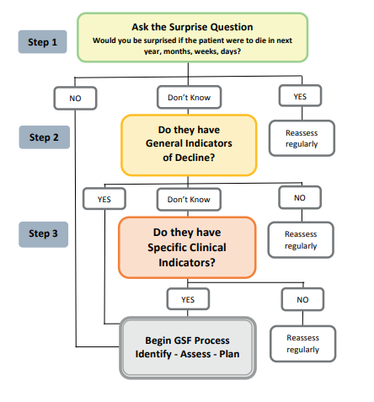
The GSF Proactive Identification Guidance (PIG) June 2022 vs7 © The Gold Standards Framework Centre in End-of-Life Care.

